Task:

1. Find current working directory

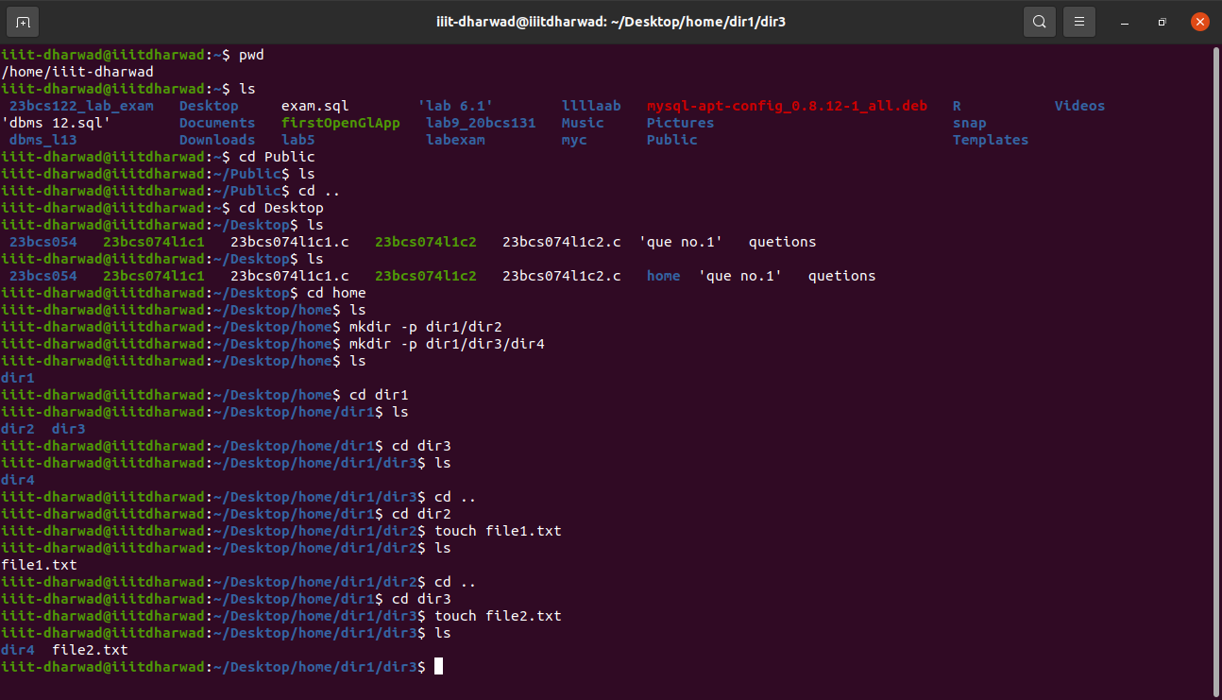

1. Navigate to the home folder



3. Find the contents of the home folder

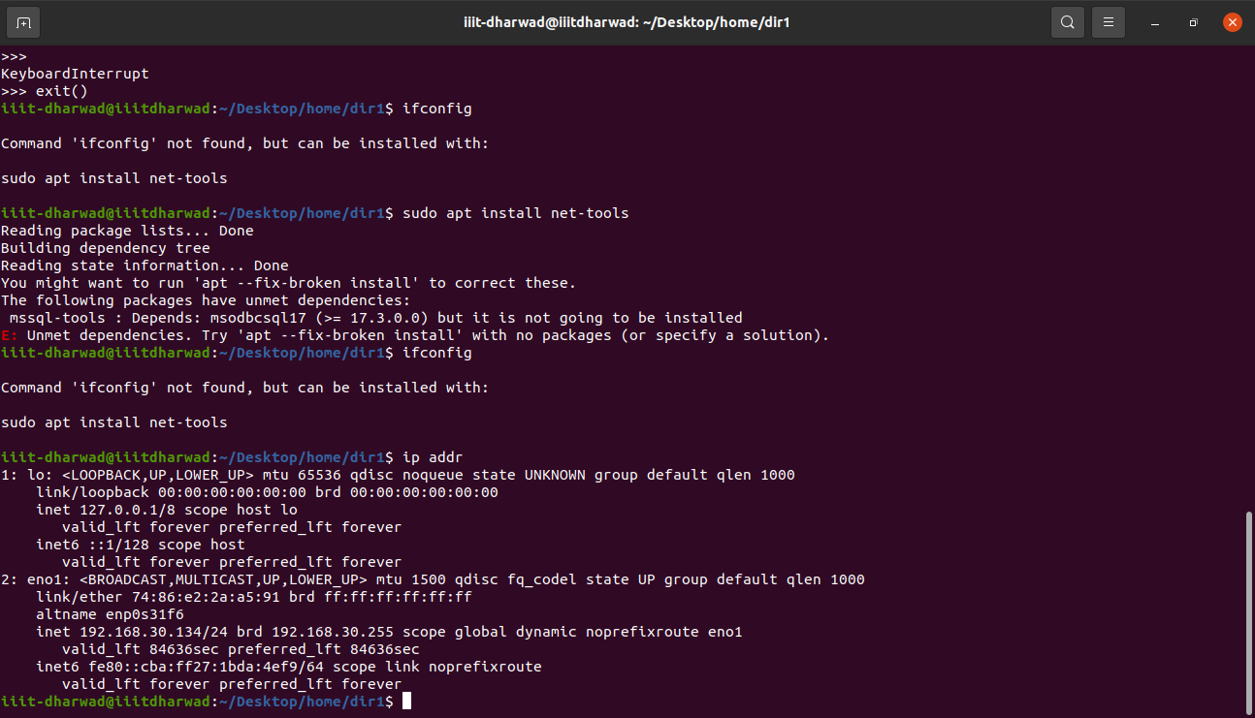

4. Create a dir structure within home directory

5. Create file1.txt and file2.txt in dir 2 and dir3



6. Edit the files and put any content

7. Copy file1.txt to dir1

8. Move file2.txt to dir1

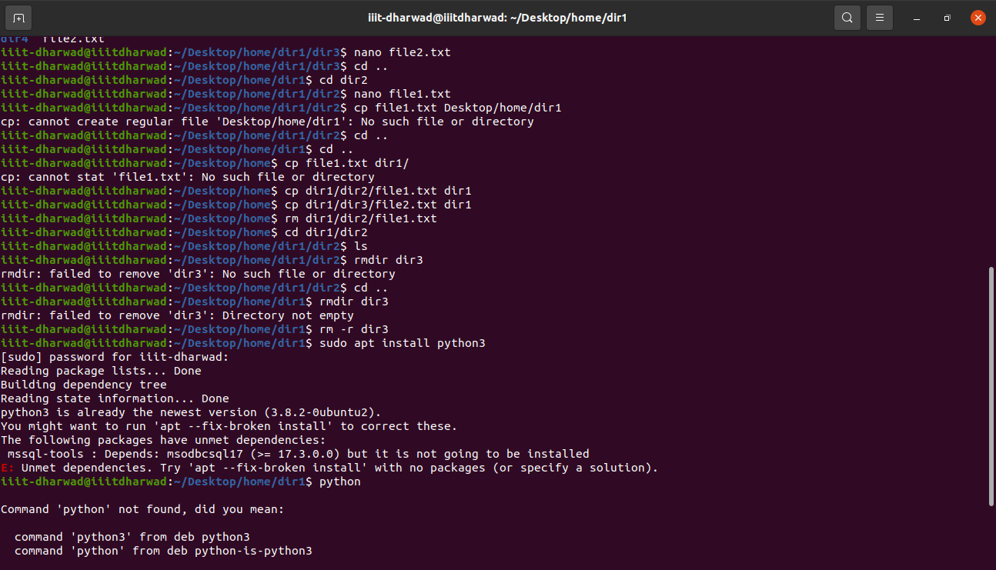

9. Delete file1.txt from dir2

10. Delete dir3



11. Install Python3

12. Write and Run a Program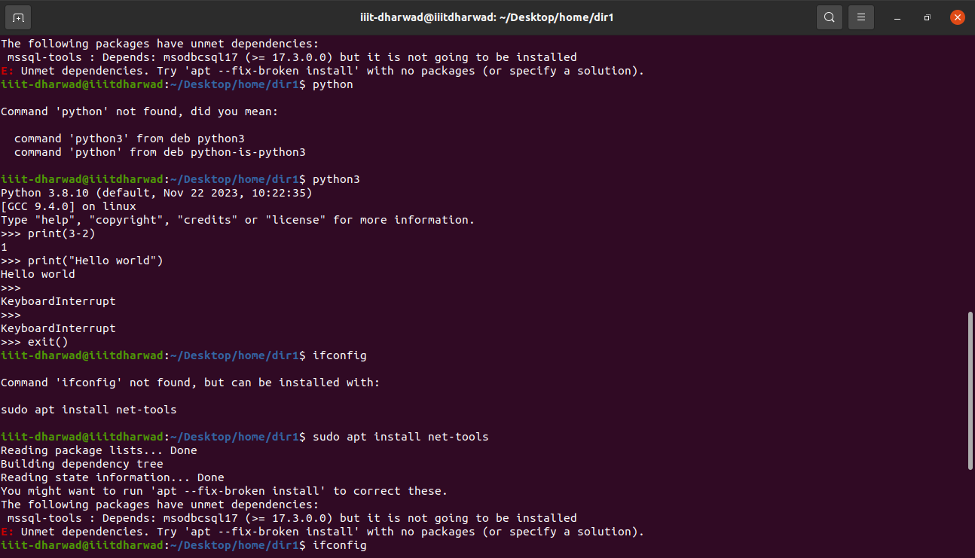

13. IP Address of System

